

PROJECT REPORT ON MAKING A WEBSITE USING HTML, CSS AND JAVASCRIPT

TOPIC: RESTAURANT

Program: B-Tech in CSE

Semester: 1st year 1st sem

Name of University: Lovely Professional University

Date of Submission: 1st December 2022

Submitted to: Dr. Mohammad Faiz

Course Code: CSE326

Project done by:

|  |  |  |
| --- | --- | --- |
| S.J.Amith | 12206508 | 57 |
| Abhishek Maharana | 12201599 | 69 |
| Raghuveer Kumar | 12200665 | 72 |

TAGS USED

* <MARQUEE>
* <CLASS>
* <IMG SRC>
* <IFRAME >
* <A HREF>
* <DIV>
* <UL> AND <LI>
* <TD> AND <TR>
* BACKGROUNG-IMAGE
* FLOAT
* POSITION
* FONT-DECORATION
* PADDING
* BORDER
* TRANSITION
* DISPLAY
* BACKGROUND-COLOR
* FONT-SIZE
* MARGIN-(TOP,BOTTOM,LEFT,RIGHT)
* FONT-FAMILY
* TEXT-ALIGN

HOME

This is the home page of our website. We have used marquee, linear-gradient… tags in this webpage. Our website is a collection of individual webpages connected with hyperlinks in the home page. By this way we could maximise the efficiency of making this website. We have made a custom logo for our website using photoshop and even made transition effects for the menu bar.

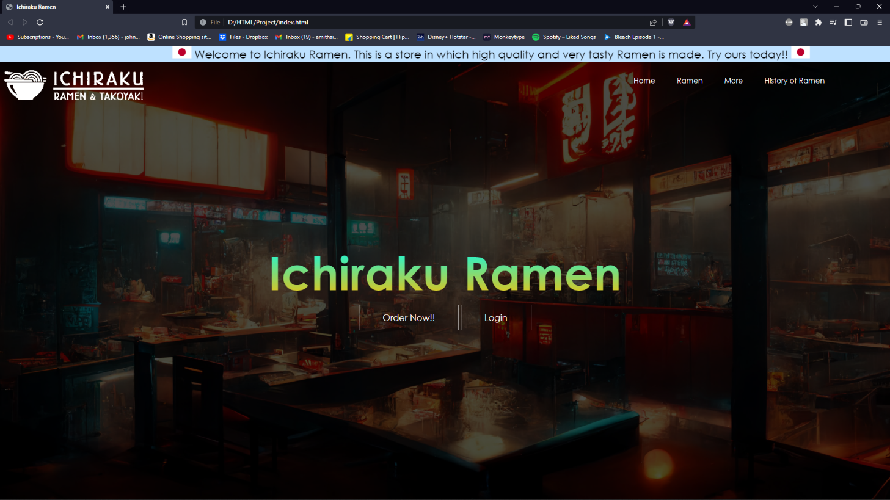

We have used the hover, UL and LI tags to get this menu bar look. We have used linear gradient and transparent font style to get the main title look. We tried a lot of colour combinations but we went with this combination so that it stands out and the customer’s attentions directly gets transferred to the title and begins surfing the website.

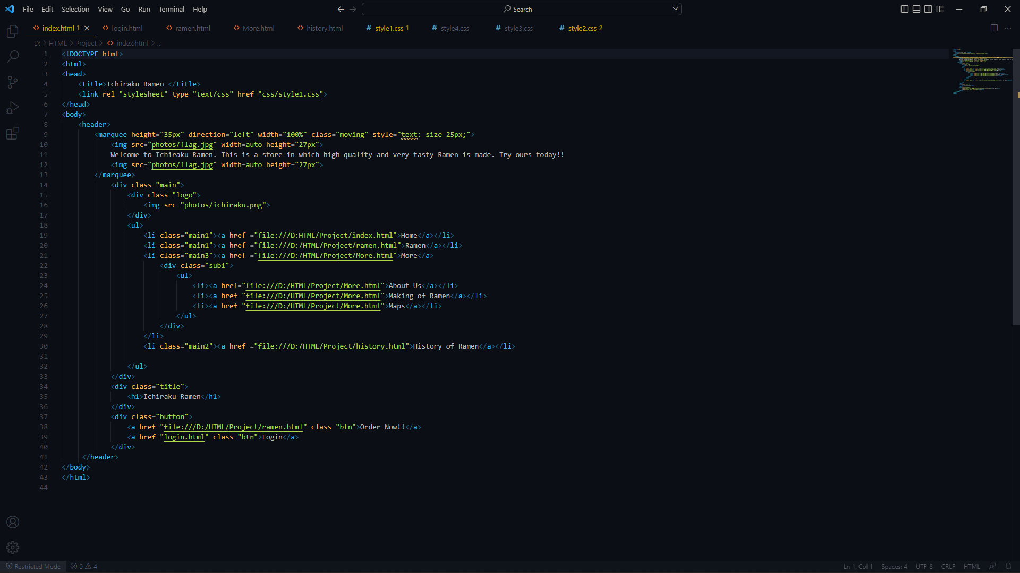

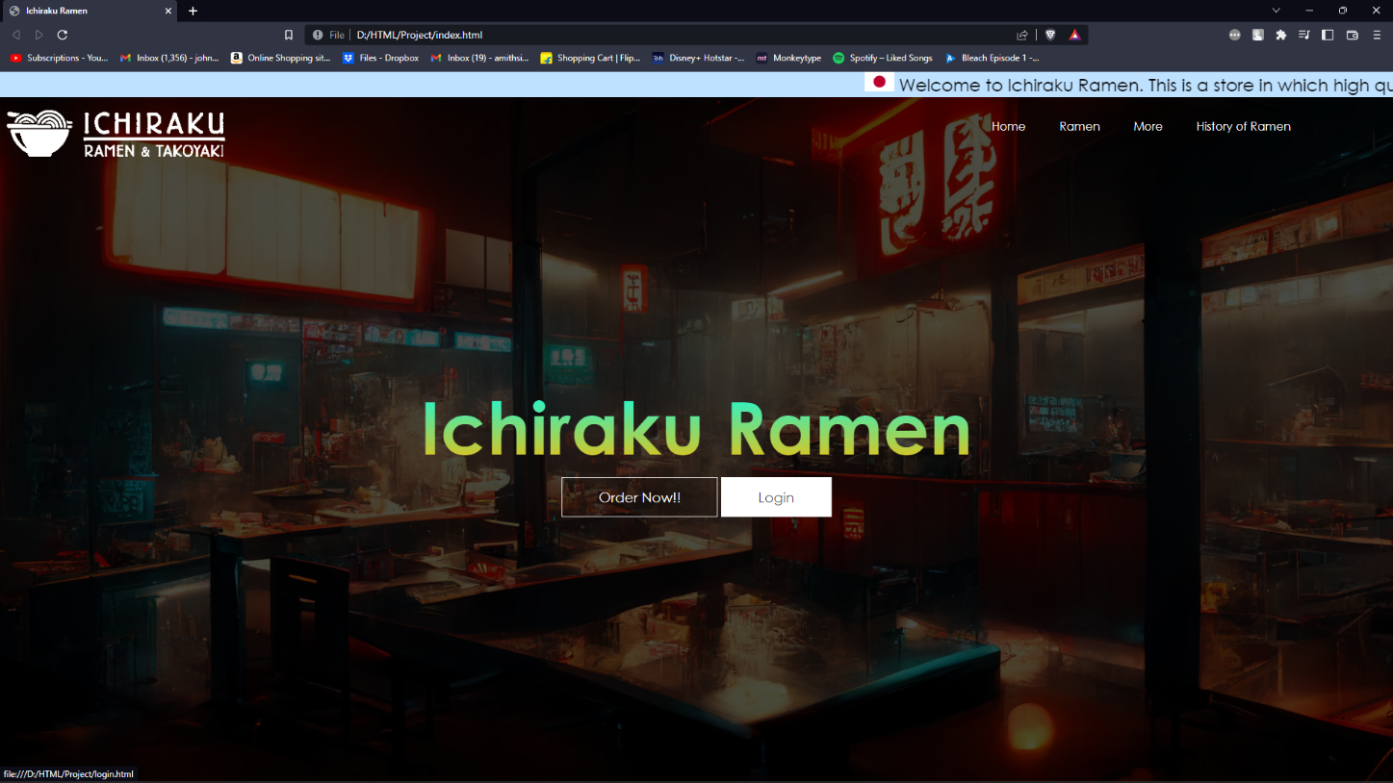

Our main goal is to keep the website as minimalistic and professional as possible. So we went for this very modern looking design. We used linear gradient attribute and messed around with the RGBA values to get this dim background look.

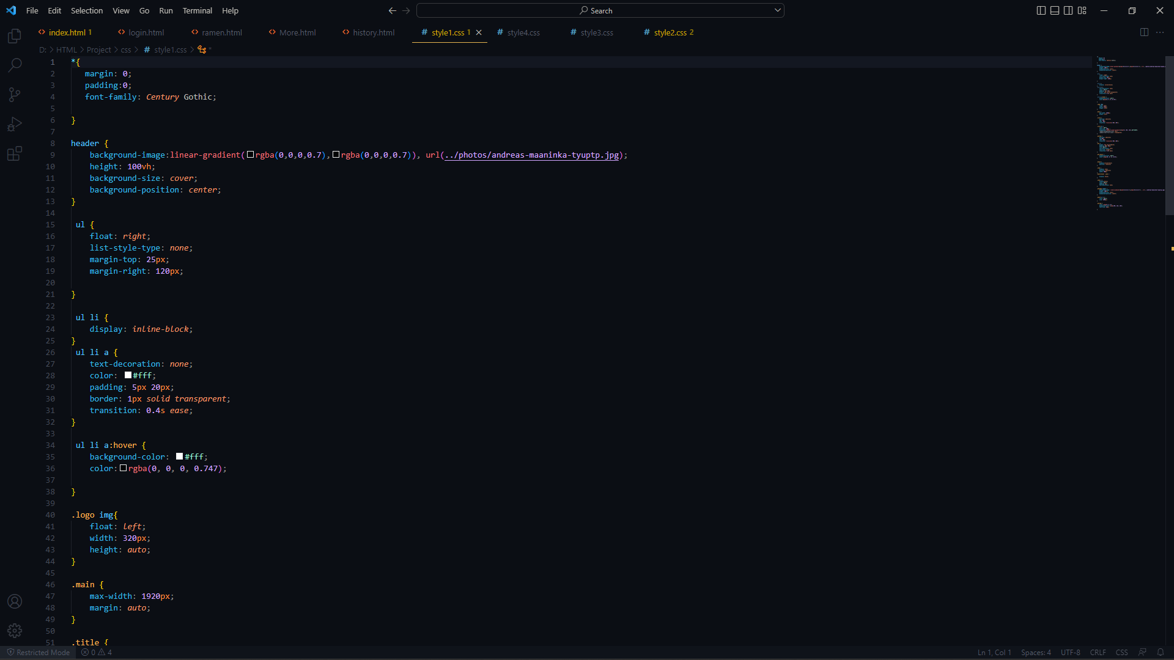

We used transition attribute to get this effect when you hover over the menu bar. We even used marquee tag for the top moving bar to attract customers.

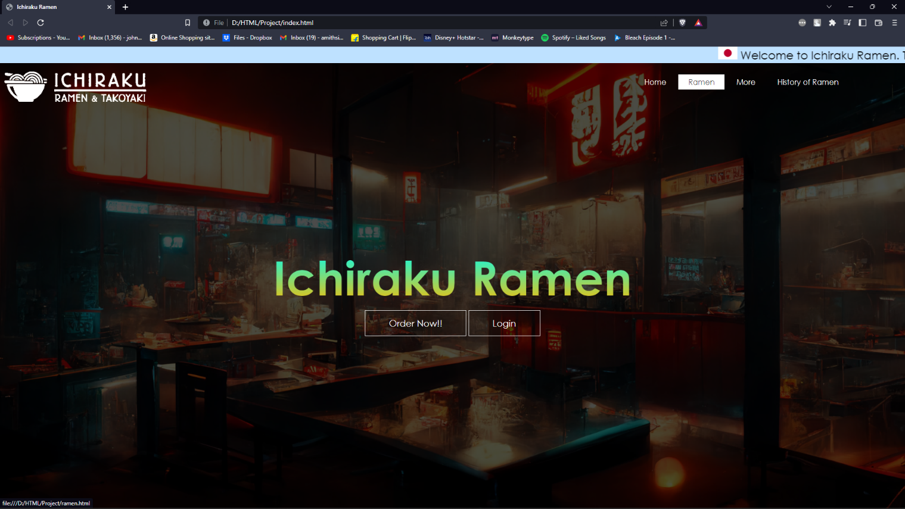

MENU

As we have chosen Ramen shop to represent, we have a very limited types of ramens to work with. But we used most things with at most efficiency. By using table tag we made a grid of the dishes and making the border 0px we achieved this clean look. We have added a special feature that when clicked on the dish you are interested in, it redirects to a external site which has the information about the interested dish. By this you can also learn about your favourite dish.

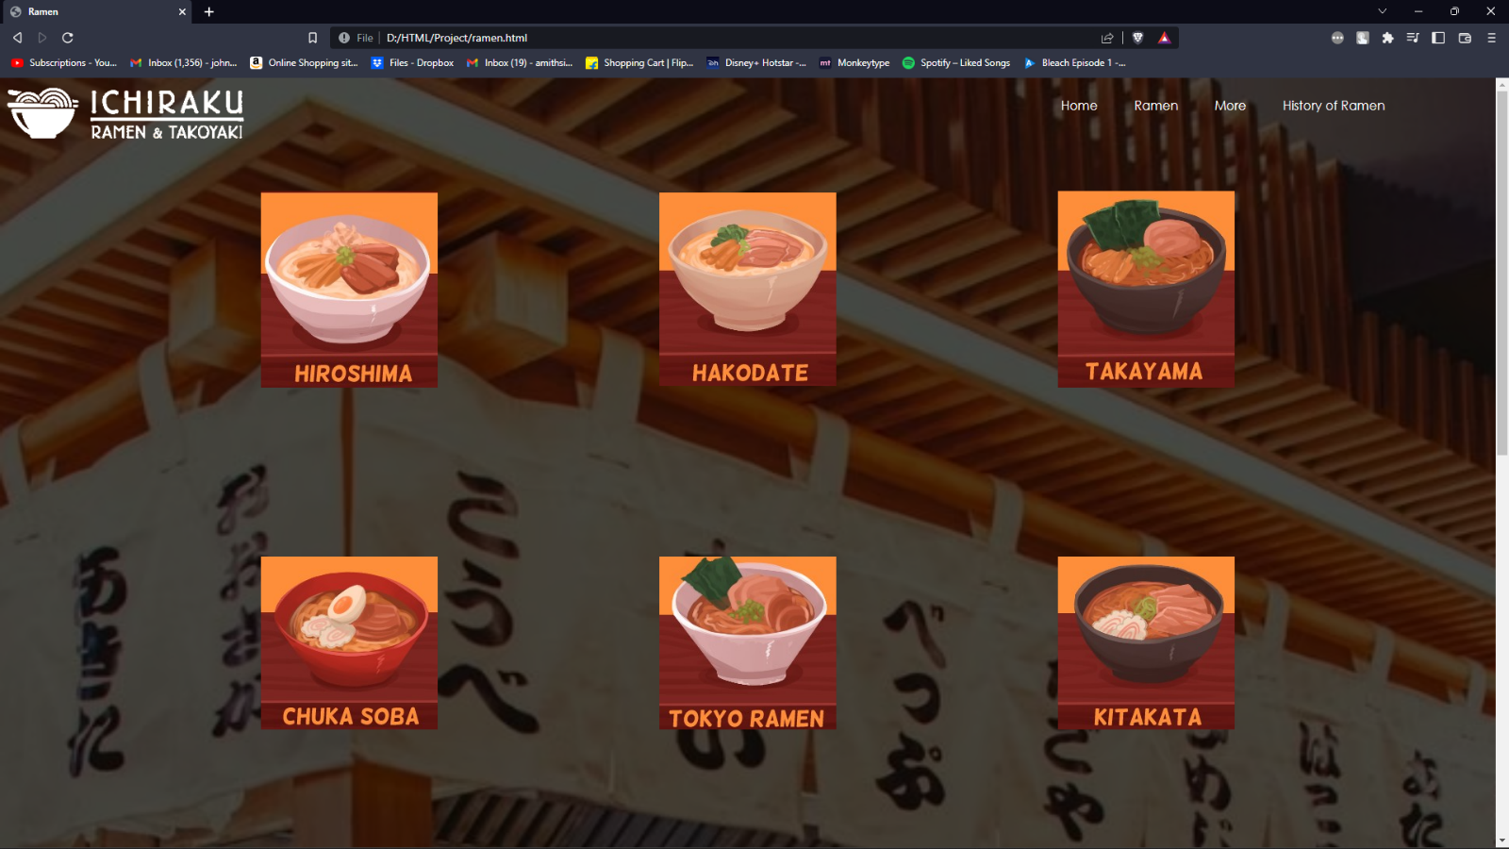

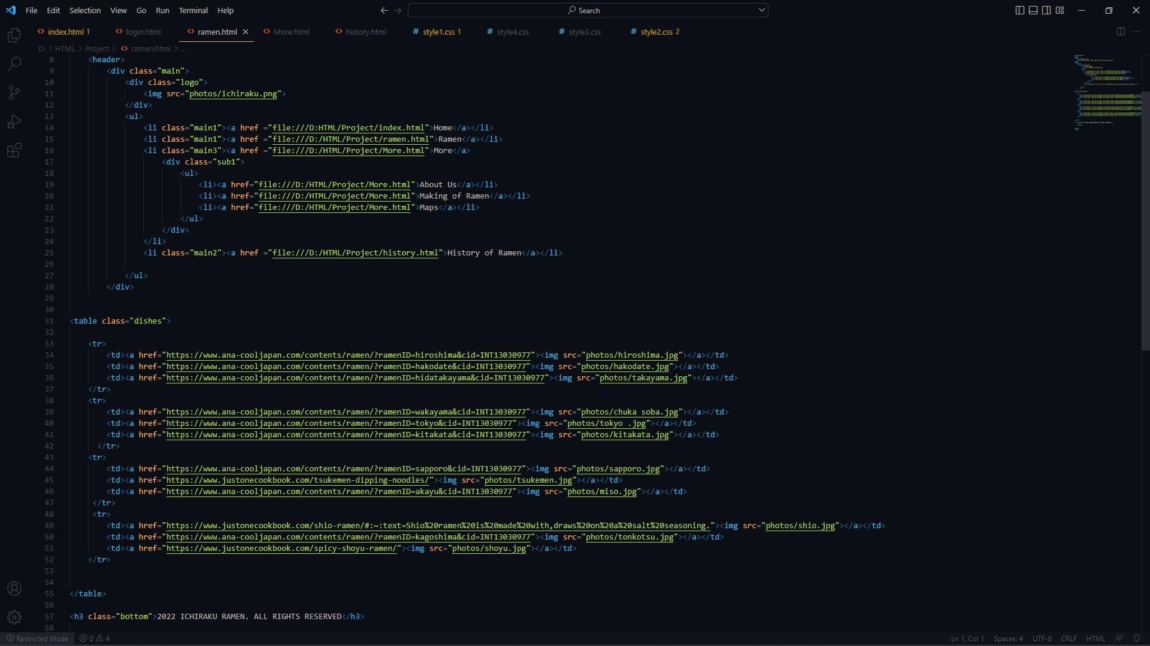

We even made the wallpaper to strect without repeating itself to maintain the clean look.

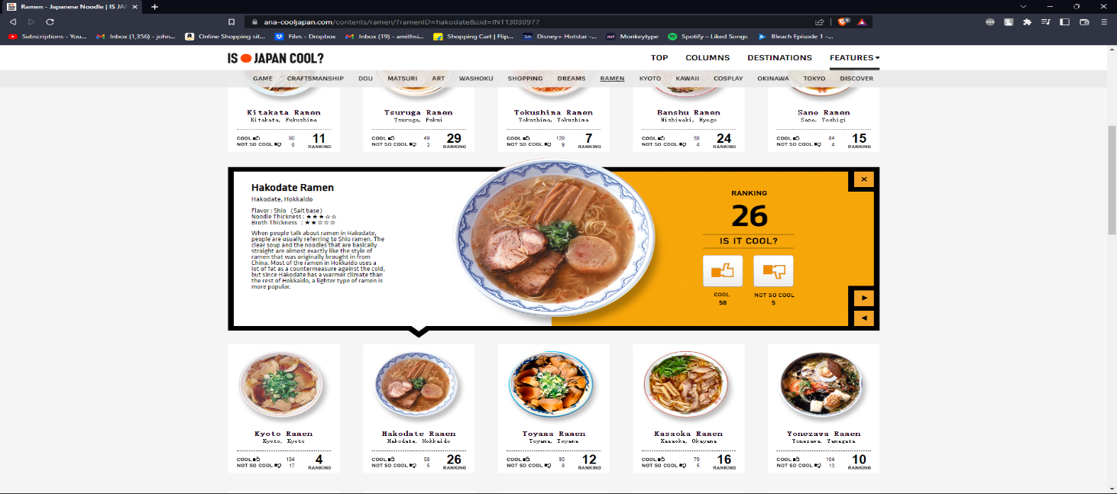

HISTORY OF RAMEN

We not only wanted to make a website to sell Ramen but also to educate people who do not have any knowledge about Ramen and attract pottential customers and expanding the business. For that to happen we created a small history class on Ramen explaining the roots of the dish and a basic idea of how its made. This was also done by using table tag.

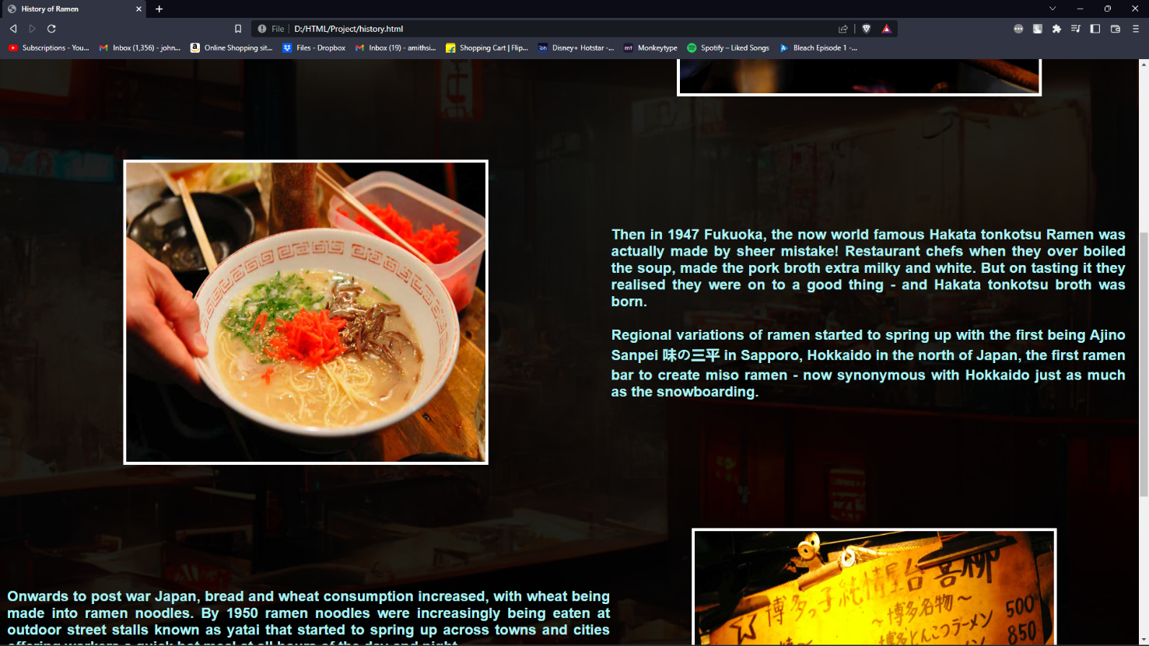

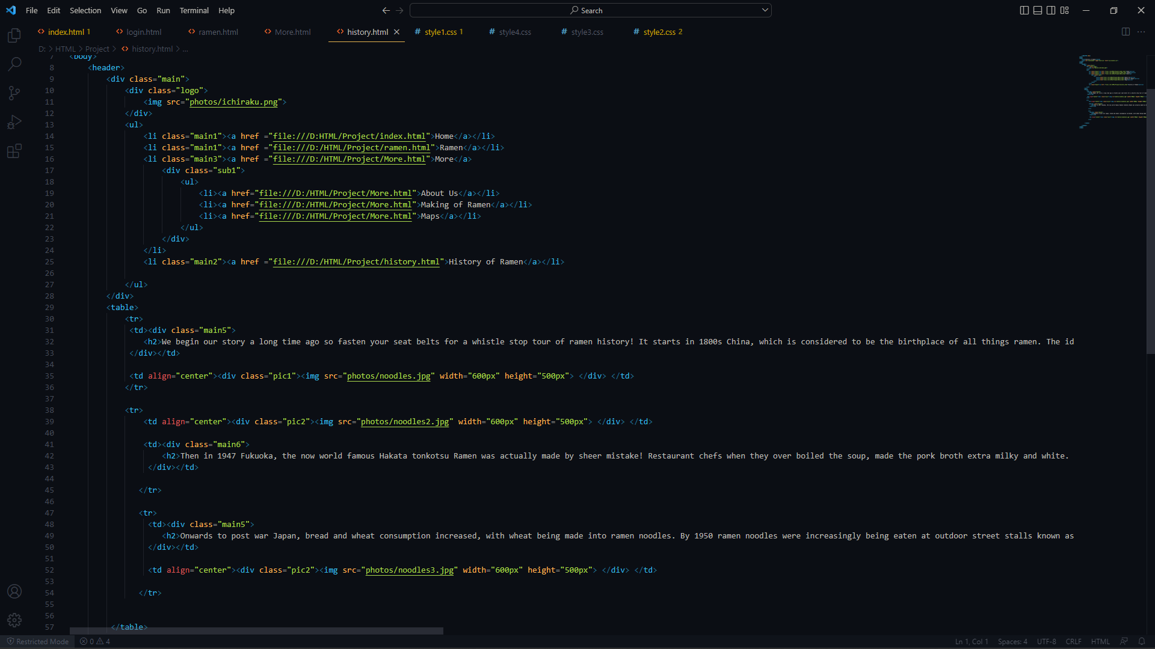

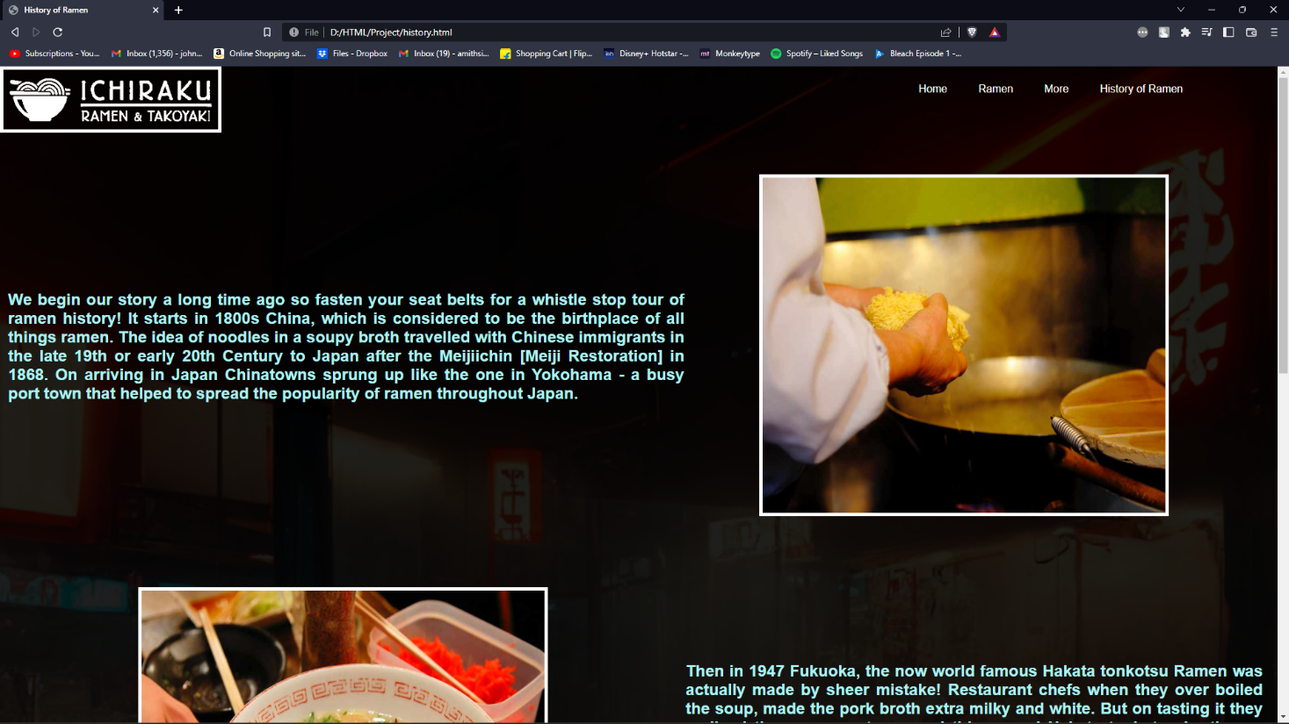

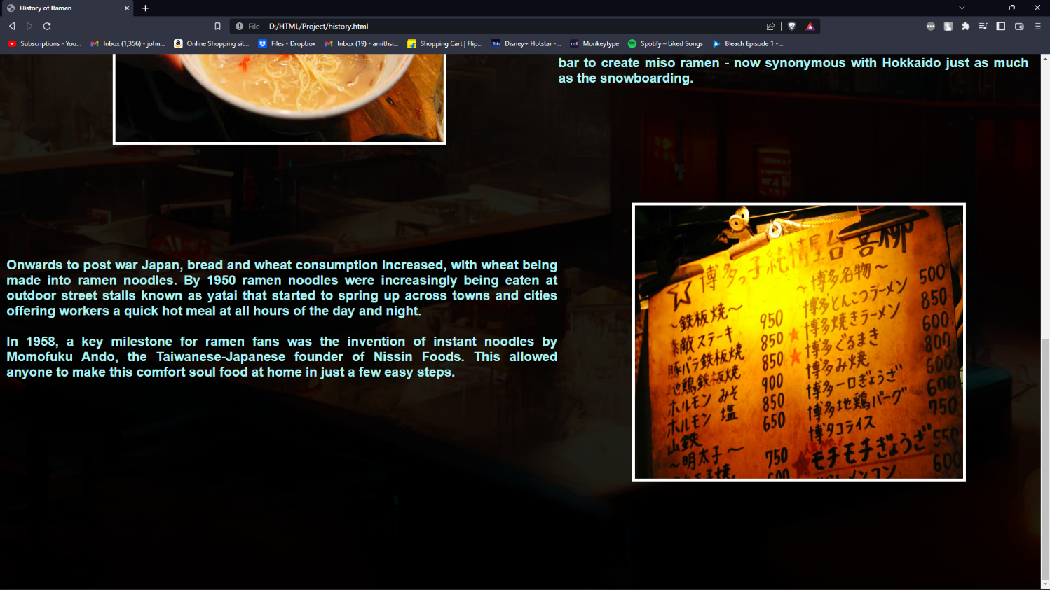

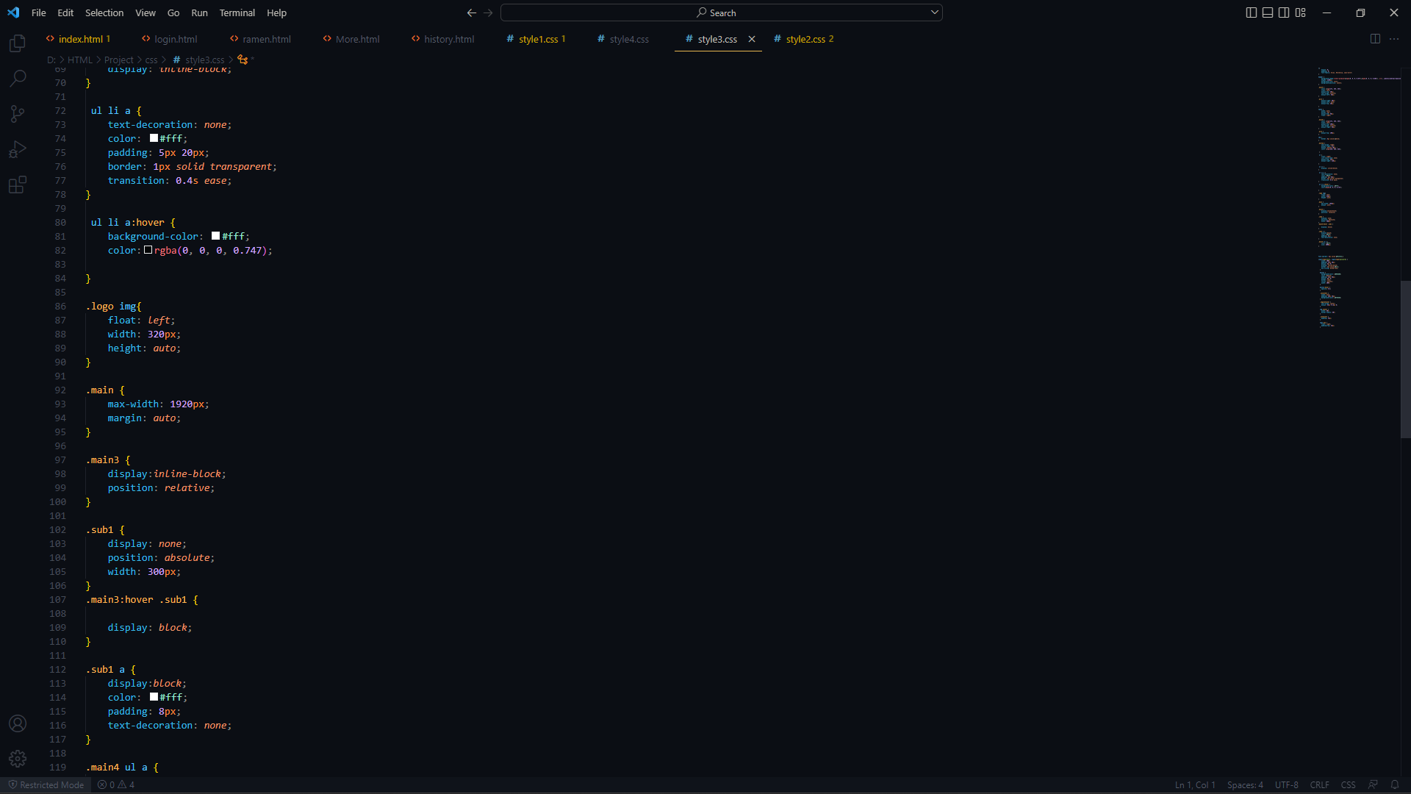

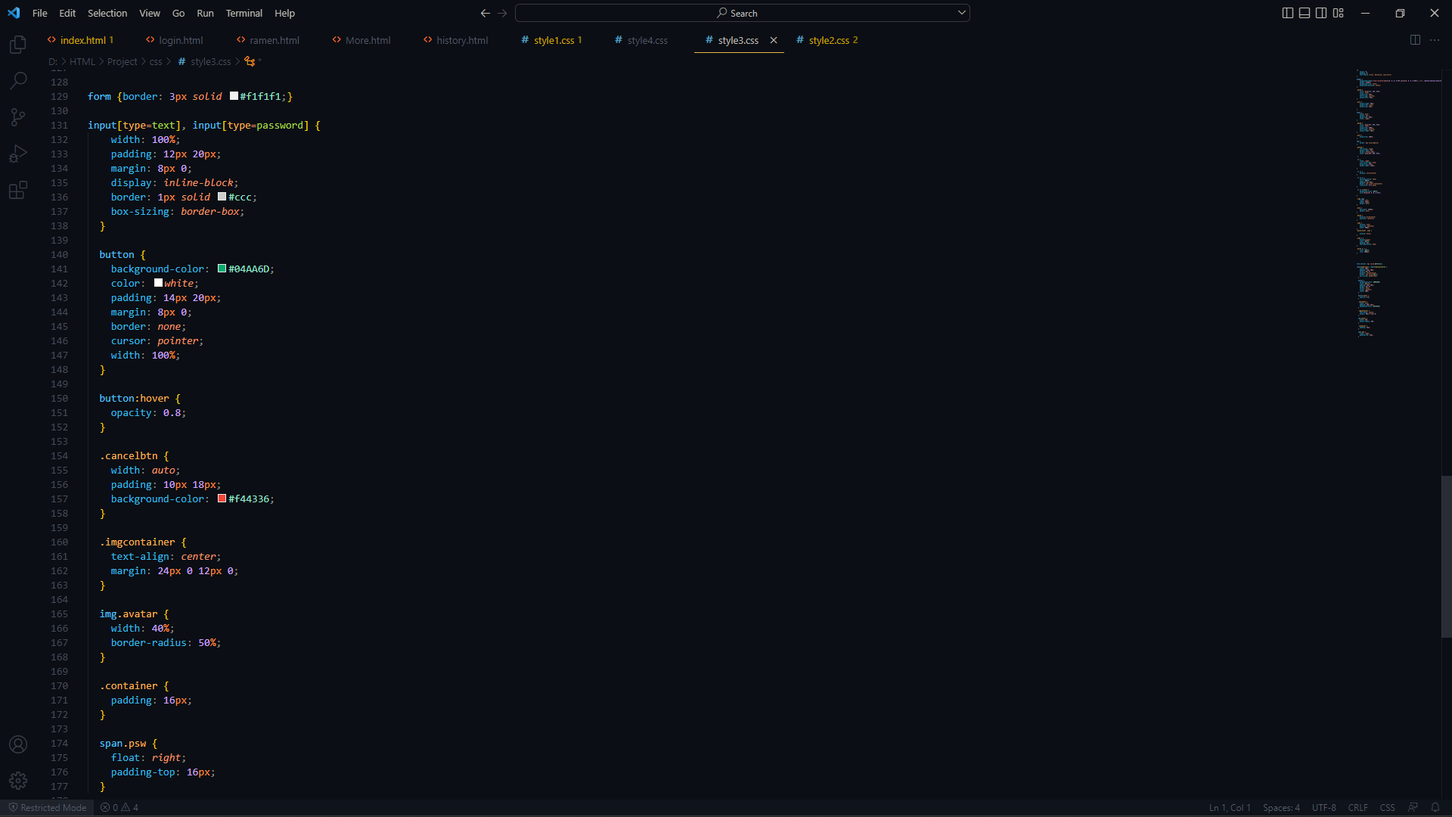

MORE

In this section we have divided it into three sections. These are also done by table tag. In this we have created a small imaginary backstory of the store, and how it came into existance. We have also used japanese words to make it sound more authentic and real and make the customer immersed into the tradition.

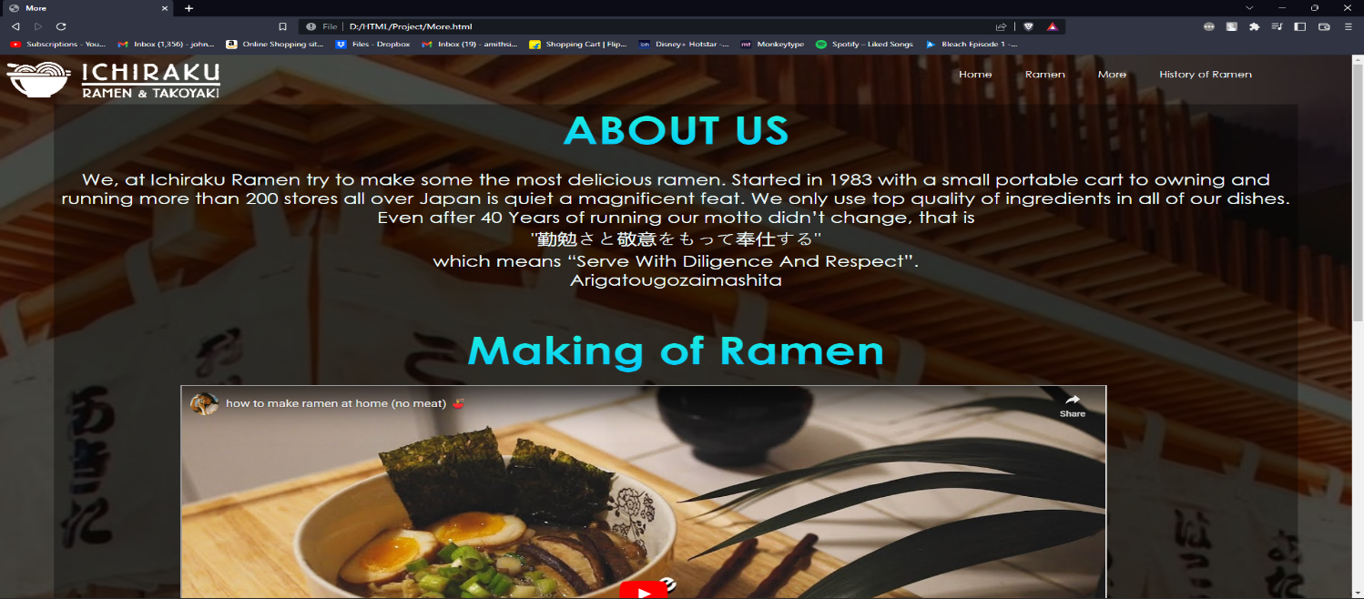

We have also used the tags such as iframe to play a youtube video as in a sandbox and show the customer how to make ramen at home also in a simple way. We have played around with height and width of the player to integrate it into the webpage and not make it look like out of place.

We even used that tag to embed a google map showing ramen stores in the area of TOSHIMA CITY, JAPAN. Its reason is to show the ramen stores in the area and also to show that iframe tag can be also used to embed maps, documents, and many more.

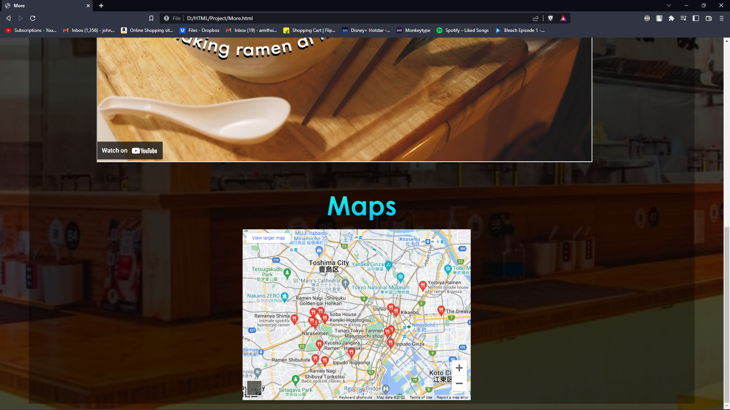

LOGIN PAGE

We have created this feature using the JAVASCRIPT. With this the user can login anywhere and anytime and still access his orders and book from anywhere using his account. We have integrated the login button under the title for easy access. We have also implemented the password alerts such that when the password is less than 6 letters it will show an error to the user and prompt the user to use a bigger and difficult password. This ensures so that the password is not too weak and hackers can brute force their way in.

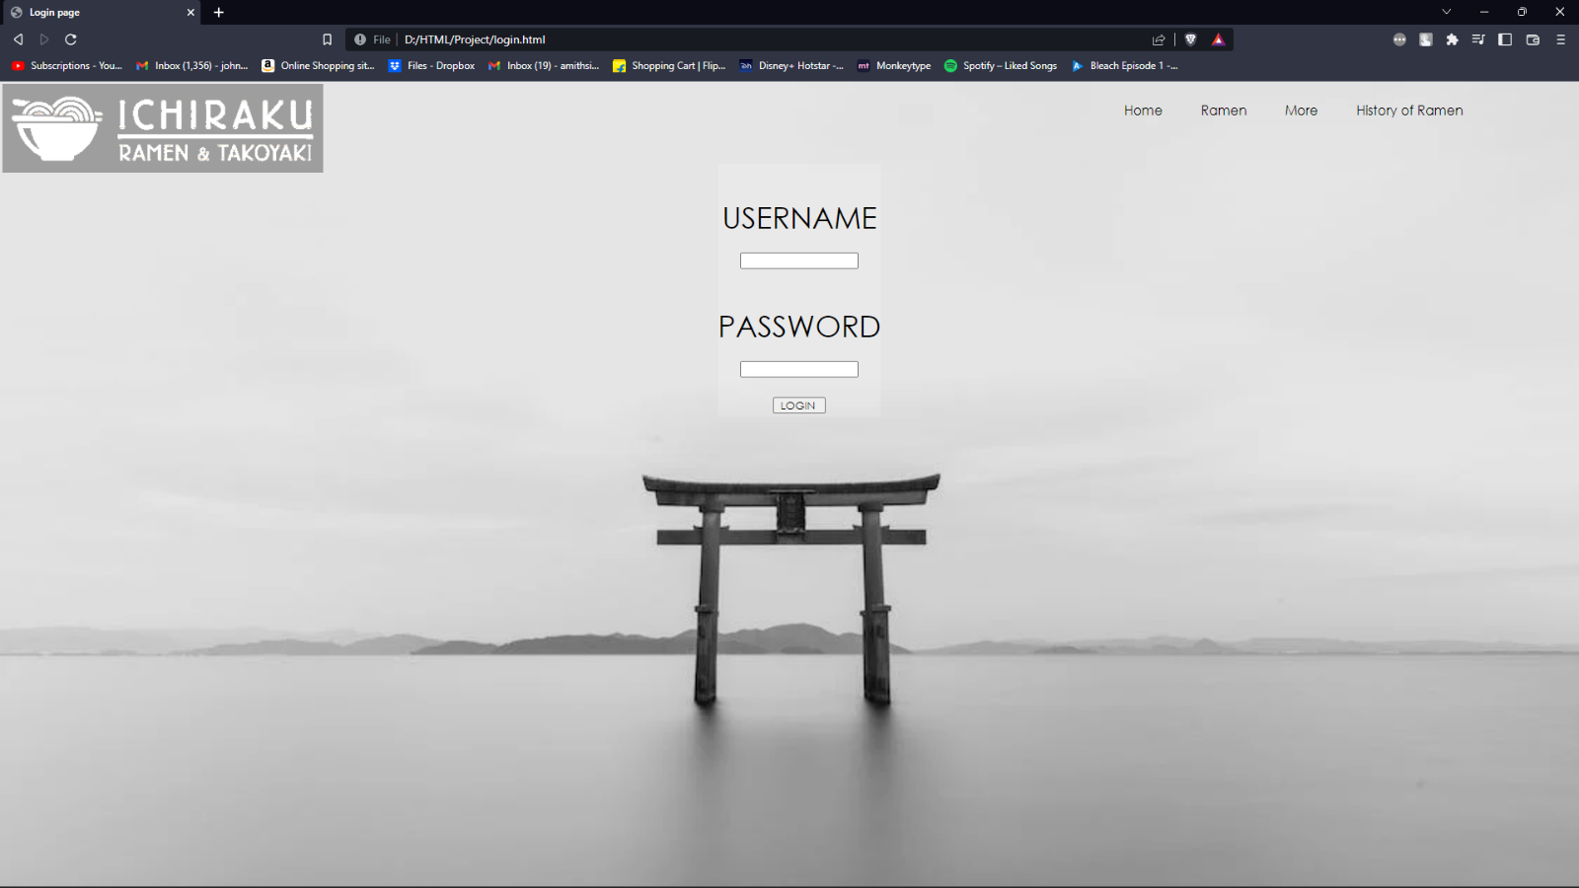

Error shown when username is not entered.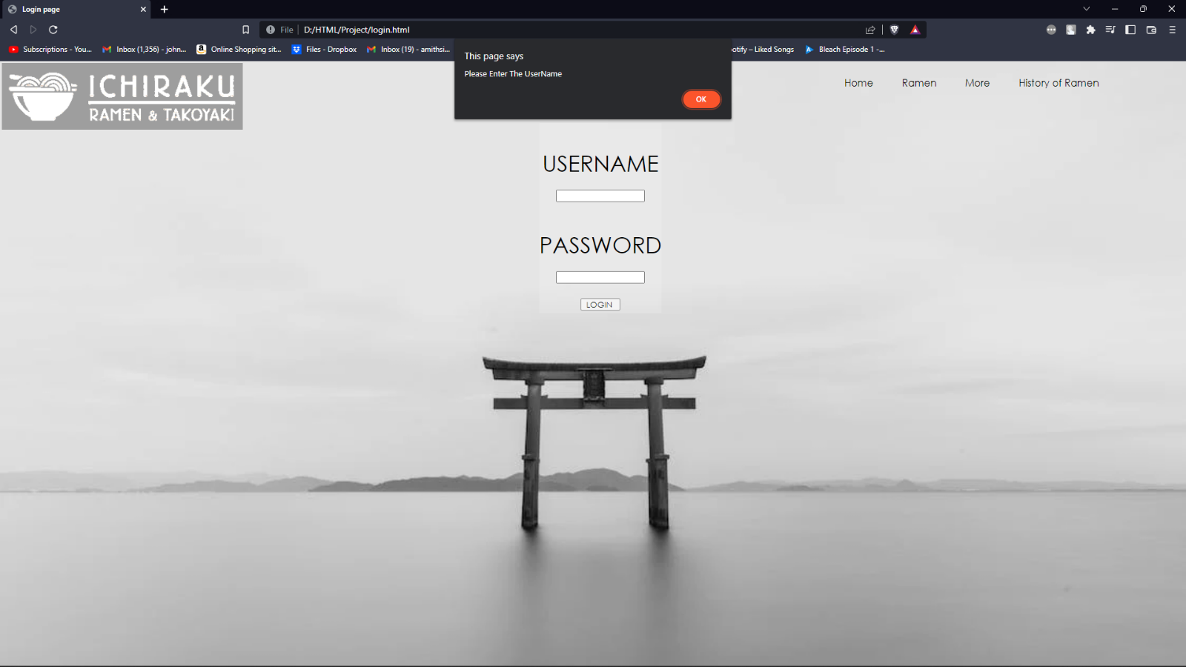

Error shown when password is not entered.

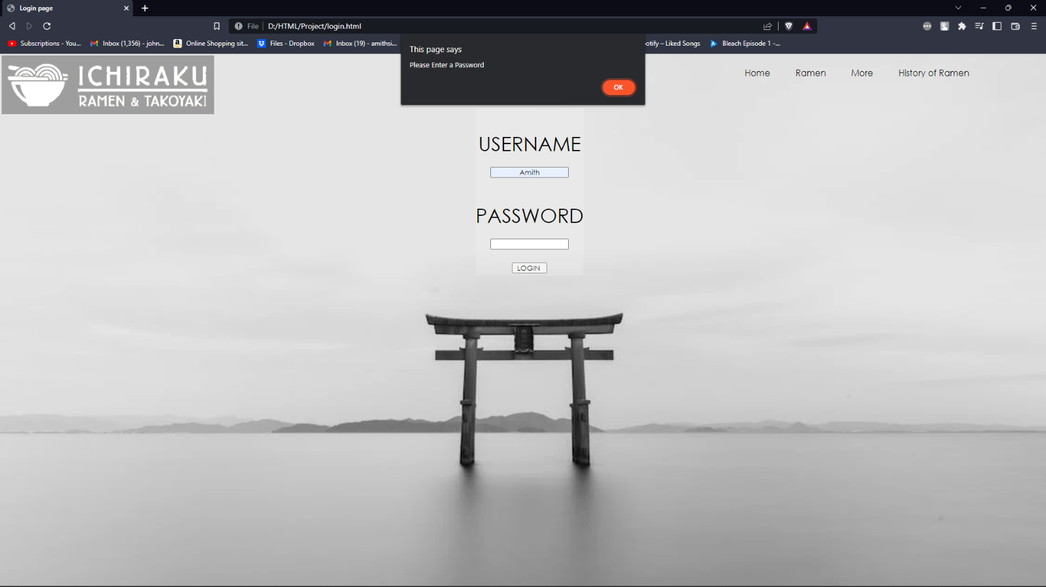

Error shown when the password is not satisfying the condition of having greater than 6 letters.

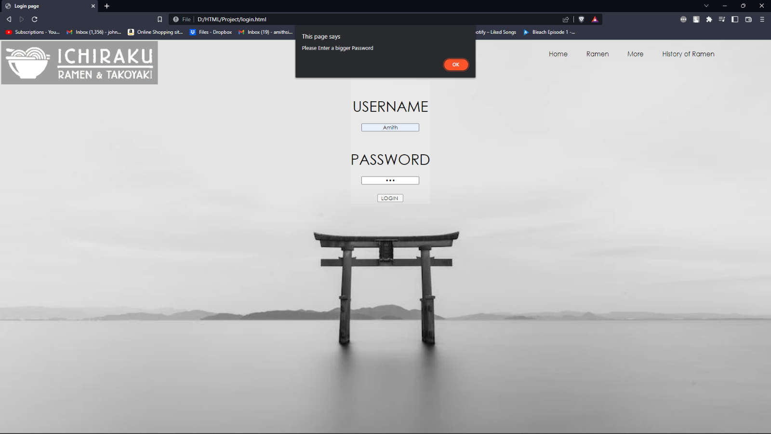

When all conditions are met then, on clicking the LOGIN button the page is redirected to the HOME page.

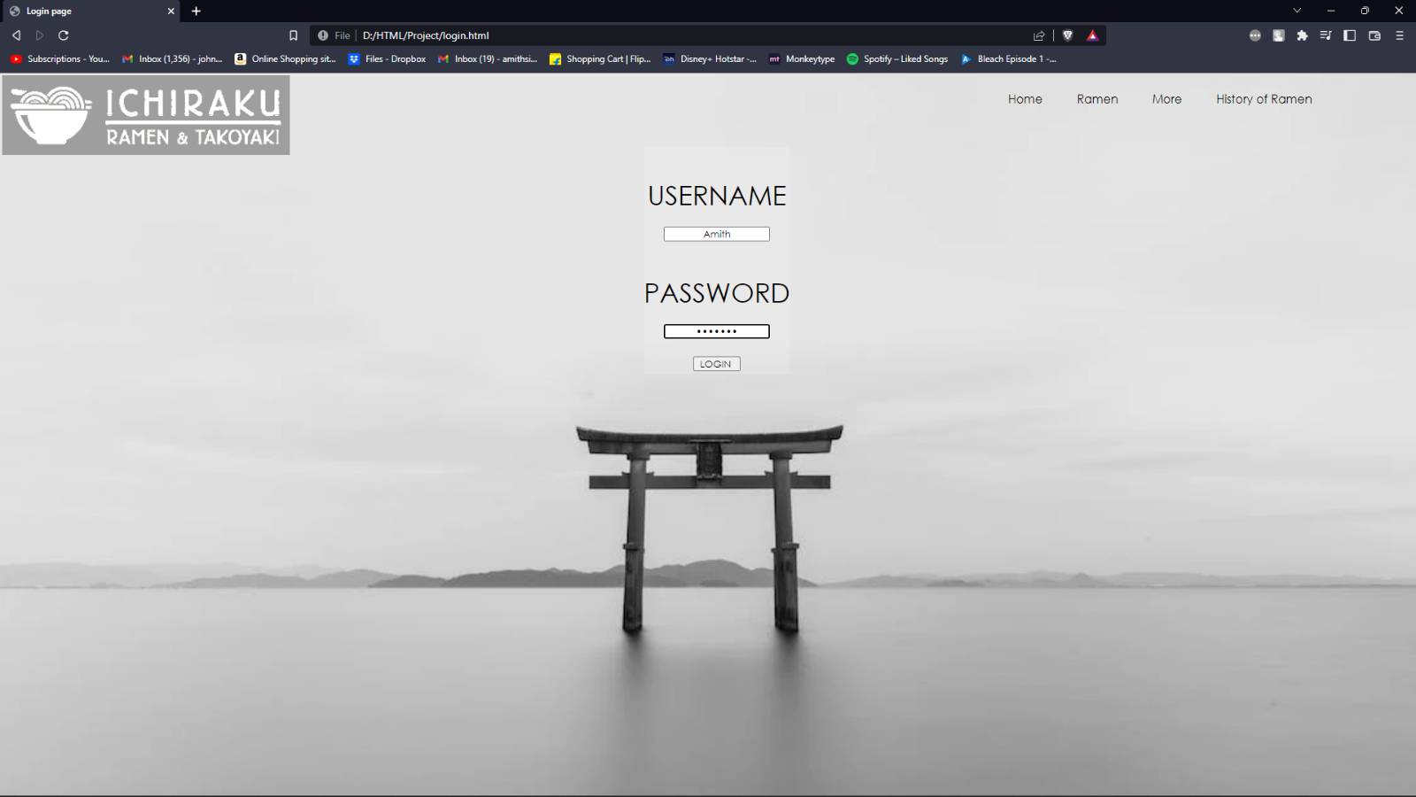

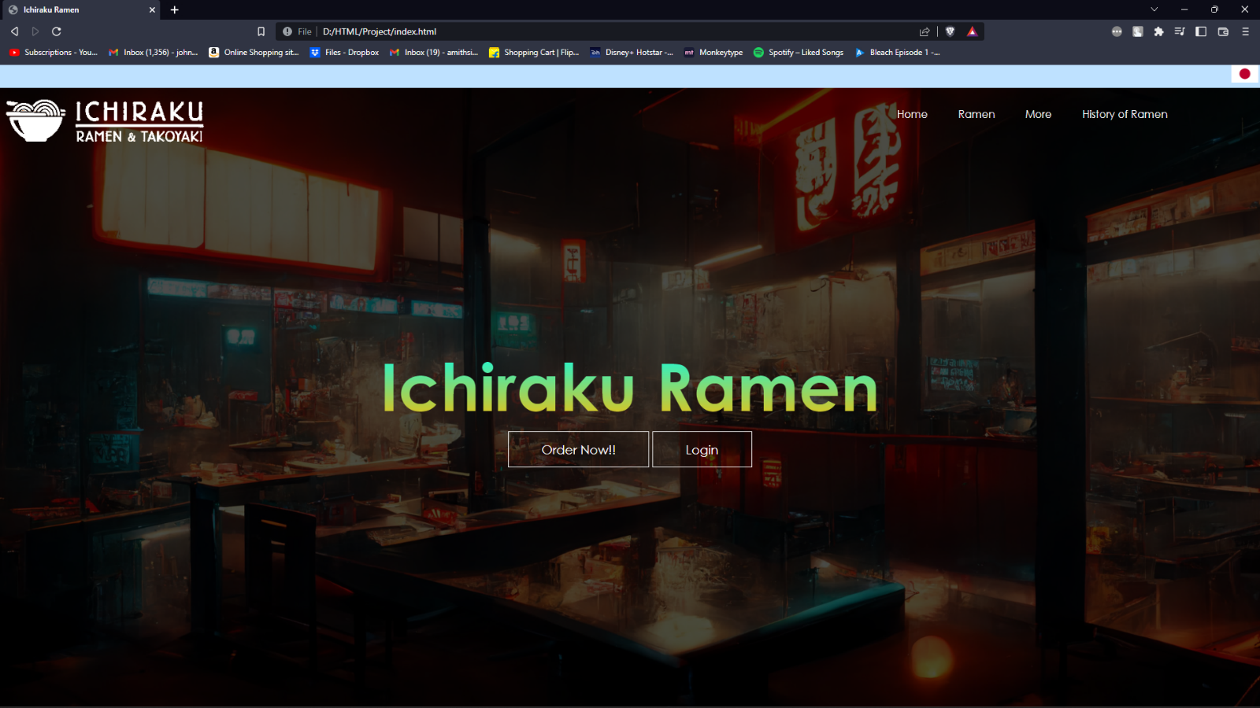

This is the JavaScript of the login page.

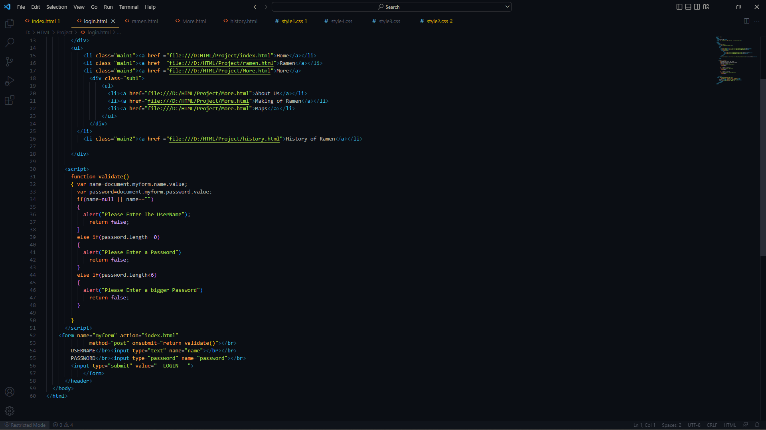

END NOTE

We have learnt a lot through this project. We understood that creating a website is no easy task and is challenging every time, but that’s where the fun lies. Having obstacles on the path makes the path interesting and challenging. We have just started to scratch the surface of wonders of HTML, CSS and JavaScript. The only limit is the creators creativity.

We once again thank our sir for giving us such a interesting project for making.

REFERENCES

* W3schools.com
* Youtube.com
* Wikipedia.org
* Google.com
* Parents and seniors

